AI-Powered Mental Health & Depression Support System.

[2025-2026]
Project Phase-I Report

Bachelor of Technology

(INFORMATION TECHNOLOGY)

Supervised by: Submitted by:
Ms. Jyoti Tiwari Khushi soni [Professor]
0801IT233D0
2 [Information Technology]
Komal Jatiya
0801IT222D03
[Information Technology]

DEPARTMENT OF INFORMATION TECHNOLOGY

SHRI GOVINDRAM SEKSARIA INSTITUTE OF TECHNOLOGY AND SCIENCE, INDORE (M.P.)

SHRI GOVINDRAM SEKSARIA INSTITUTE OF TECHNOLOGY AND SCIENCE, INDORE (M.P.)
A Govt. Aided Autonomous Institute, Affiliated to RGPV, Bhopal
DEPARTMENT OF INFORMATION TECHNOLOGY


CERTIFICATE
This is to certify that the Dissertation Phase-I “AI-Powered Mental Health & Depression Support System”submitted by Khushi Soni, Komal Jatiya is accepted in partial fulfillment of the degree of Bachelor of Technology in Information Technology of Rajiv Gandhi Proudyogiki Vishwavidyalaya, Bhopal during the session 2025-2026.

Internal Examiner External Examiner
Date: Date:

ABSTRACT

In the contemporary era, the global population is witnessing an unprecedented escalation in mental health disorders, specifically depression, anxiety, and chronic stress. According to the World Health Organization (WHO), depression is a leading cause of disability worldwide, yet a staggering proportion of sufferers fail to receive adequate care. The barriers to entry for professional mental healthcare are multifaceted, ranging from prohibitive financial costs and geographic inaccessibility to the pervasive social stigma associated with seeking psychological help. Consequently, there is an urgent and critical need for accessible, scalable, and non-judgmental interventions that can bridge the widening gap between the demand for care and the supply of professional therapists.
To address these systemic inefficiencies, this project proposes the development of an AI-Powered Mental Health & Depression Support Platform. This comprehensive, web-based ecosystem is designed to democratize access to mental wellness tools by leveraging the transformative power of Artificial Intelligence. Unlike traditional, static self-help applications that offer generic advice, this platform introduces a paradigm shift towards "Active Digital Therapeutics." The core innovation lies in its real- time AI Avatar Companion, driven by advanced Large Language Models (LLMs) and Multimodal Emotion Recognition algorithms. This avatar serves as an always-available empathetic listener, capable of engaging users in therapeutic conversations derived from Cognitive Behavioral Therapy (CBT) frameworks.
The system is architected as a holistic "All-in-One" wellness hub. It integrates diverse therapeutic modalities including an emotion-sensitive music therapy engine, AI-guided meditation sessions, and computer-vision-assisted yoga exercises that utilize MediaPipe for real-time pose correction. Furthermore, the platform employs a sophisticated mood tracking system that visualizes emotional trends over time, enabling data-driven personalization of daily activities. Built upon a robust technology stack featuring React.js, Node.js, Python, and MongoDB, the system ensures high performance, security, and scalability.

Table of Contents

Certificate | 1
Abstract | 2
List of Figures | 9
1 INTRODUCTION | 1
1.1 Overview . . . . . . . . . . . . . . . . . . . . . . . . . . . . . . . . . . . | 1
1.2 Objectives . . . . . . . . . . . . . . . . . . . . . . . . . . . . . . . . . . . | 2
1.3 Problem statement . . . . . . . . . . . . . . . . . . . . . . . . . . . . . . | 3
2 LITERATURE REVIEW | 4
2.1 Evolution of Digital Mental Health . . . . . . . . . . . . . . . . . | 5
2.2 Theoretical Framework: Cognitive Behavioral Therapy (CBT) . . . . . | 6

- SYSTEM DESIGN 9
  - Existing Systems . . . . . . . . . . . . . . . . . . . . . . . . . . . . . . . 9
  - Proposed System . . . . . . . . . . . . . . . . . . . . . . . . . . . . . . . 9
  - System Architecture . . . . . . . . . . . . . . . . . . . . . . . . . . . . . 10
    - High Level Architecture . . . . . . . . . . . . . . . . . . . . . . . . 10
    - Technology Stack . . . . . . . . . . . . . . . . . . . . . . . . . . . 11
  - Functional Module . . . . . . . . . . . . . . . . . . . . . . . . . . . . . . 12
    - The API Management Gateway (Module 1) . . . . . . . . . . . . . . 12
    - The Core Analysis Engine (Module 2) . . . . . . . . . . . . . . . . 12
  - The Three Layer Detection Strategy . . . . . . . . . . . . . . . . . . . . . 13
    - Layer 1: Foundational Checks (Safety & Crisis 13
Detection). . . . . . . . . …..
    - Layer 2: Heuristic and Context Analysis (The "Live Context") 14
    - Layer 3: Machine Learning Core (The "Therapeutic Engine") 14
  - System Modeling (UML Diagrams) 16
    - Use Case Diagram 16
    - Class Diagram 17
    - Sequence Diagram 18
    - Activity Diagram 19
    - Deployment Diagram 19
- IMPLEMENTATION
- CONCLUSION 24
REFERENCES 25

LIST OF FIGURES

Fig. No. Title Page No.

  - Evolution of Digital Mental Health . . . . . . . . . . . . . . . . . . 5
  - Theoretical Framework: Cognitive Behavioral Therapy (CBT). . . . . . 6

  - Use Case Diagram 16
  - Class Diagram 17
  - Sequence Diagram 18
  - Activity Diagram 19
  - Deployment Diagram 20

Chapter 1

INTRODUCTION

  - Overview

In the rapidly evolving landscape of healthcare technology, the domain of mental health has traditionally been tethered to synchronous, in-person clinical interactions between clinicians and patients. However, the sheer scale of the global mental health crisis—exacerbated by modern stressors—has rendered this manual model insufficient, necessitating a paradigm shift towards scalable "e-Mental Health" solutions. This project, the AI-Powered Mental Health & Depression Support Website, represents a significant leap forward in this domain, conceptualized as a sophisticated "Digital Therapeutic" ecosystem rather than a passive informational portal. It serves as an intelligent, always-available "First Line of Defense," designed to intervene during the critical windows of distress when professional help is often inaccessible or unaffordable.
The platform distinguishes itself by harmonizing the empathetic capabilities of modern Generative AI with evidence-based clinical frameworks. At its core is a real-time, 3D AI Avatar that transcends standard text-based chatbots by offering multimodal interaction—speaking, listening, and visually reacting to user emotions. This interaction is deeply rooted in Cognitive Behavioral Therapy (CBT) principles, allowing the system to not only listen but to actively guide users in reframing negative thought patterns and managing anxiety triggers through Socratic questioning.
Furthermore, the system recognizes that mental wellness is multifaceted. Therefore, it integrates a holistic suite of wellness tools—including emotion-sensitive journaling, AI-guided meditation, and computer- vision-assisted physical exercises—into a single, cohesive interface. By dynamically curating these activities based on the user's real-time emotional state, the platform delivers a personalized care regimen that adapts to the user's changing needs. This data-driven approach, combined with strict privacy protocols, aims to dismantle the barriers of cost, stigma, and accessibility, providing a safe harbor for emotional regulation in the digital age [6]

The motivation behind this project stems from the alarming statistics surrounding global mental health. The shortage of mental health professionals creates a massive treatment gap [2]. Furthermore, the "always- on" nature of modern life has contributed to rising levels of burnout. We were motivated by the potential of Large Language Models (LLMs) to provide instant, scalable conversational support. If an AI can assist with complex logical tasks, it can also be trained to offer empathetic, non-medical support to a lonely individual at any hour, bridging the gap left by human resource shortages [3].

Objectives

The primary objective of this project is to engineer a holistic digital mental health intervention system. The specific objectives are as follows:
    - Development of Real-Time Emotional AI: To create a conversational agent utilizing Transformer- based Large Language Models (LLMs) capable of detecting nuanced sentiment and generating empathetic, context-aware responses. Unlike traditional rule-based chatbots, this system will employ deep learning architectures to understand the semantic and emotional context of user inputs, ensuring that interactions are psychologically supportive and aligned with Cognitive Behavioral Therapy (CBT) principles.
    - Implementation of Multimodal Interaction: To integrate voice-to-text and text-to-speech capabilities, ensuring accessibility and simulating natural human conversation for users in distress. This objective focuses on reducing the friction of interaction by allowing users to speak naturally rather than typing, which is particularly crucial during moments of acute anxiety or panic, thereby making the platform accessible to users with visual or motor impairments.
    - Integration of Computer Vision for Wellness: To deploy client-side MediaPipe models for real-time body tracking, providing immediate feedback on posture during physical exercises to ensure safety and efficacy. By analyzing video streams locally on the user's device, the system will offer real-time corrections for Yoga poses (e.g., "Straighten your back"), merging physical health monitoring with mental wellness without compromising user privacy through cloud data transmission.
    - Secure Analytics and Progress Tracking: To establish a secure backend architecture with encryption for sensitive mood logs, enabling the generation of visual analytics to track emotional trends over time. This involves implementing robust database security protocols (e.g., encryption at rest) and developing a frontend dashboard that visualizes mood progression, helping users identify personal triggers and patterns in their mental health journey.
    - Creation of an Immersive Therapeutic UI: To design a visually calming user interface using React.js and Three.js that utilizes color psychology and smooth animations to reduce cognitive load and promote relaxation. The objective is to move away from clinical, sterile designs and create an engaging, warm digital environment that actively contributes to the user's sense of safety and calm from the moment they log in.

Problem statement

Global mental health is facing a serious crisis as many people are unable to access timely and affordable care. Traditional therapy is often expensive, limited by availability of professionals, and affected by social stigma, creating a large treatment gap. Although digital mental health apps exist, most of them offer only static content such as articles or meditation libraries and fail to provide real-time, empathetic support. During moments of stress or emotional distress, users need immediate assistance, but current platforms require effort to search for help or depend on scheduled and costly tele-therapy sessions. There is a clear lack of an accessible, intelligent, and emotionally responsive system that can support users anytime without judgment.
This project addresses this gap by developing an AI-Powered Mental Health & Depression Support Website that provides continuous, personalized, and stigma-free assistance. The platform consists of independent modules for better clarity and usability. An AI Avatar offers real-time emotional companionship through voice, expressions, and motivation. Separate modules provide guided meditation, stress-relief exercises, mood-based music therapy, self-help reading content, and mind games for focus and relaxation. Together, these features create a scalable, user-friendly, and emotionally supportive digital mental wellness system available 24/7.

Chapter 2
LITERATURE REVIEW

The rapid expansion of digital healthcare services has established the smartphone as a primary conduit for medical intervention. However, this ubiquity has led to the proliferation of passive "Wellness Apps"—static tools used to track moods or provide generic advice without clinical supervision. While initially beneficial for awareness, these tools are increasingly exploited for data mining and lack the capability to intervene during acute distress, leading to high user churn and fragmented care [6].To understand the advanced detection and intervention methodologies proposed in this project, it is essential to first review the evolution of digital mental health mechanisms and the theoretical frameworks required for an automated therapeutic alliance.

Evolution of Digital Mental Health
The trajectory of digital mental health interventions has evolved from passive informational repositories to sophisticated, AI-driven therapeutic ecosystems. This evolution is
not merely chronological but represents a fundamental shift in how technology interacts This evolution can be categorized into three distinct phases of technological maturity:
    - Phase 1: Digitization of Information (Web 1.0): In this foundational stage, digital mental health was synonymous with "Tele-information." Platforms like WebMD and early government health portals provided static text-based resources. While this increased access to information, it lacked personalization and failed to address the immediate emotional needs of users in distress. The primary limitation was the one-way flow of information, treating the patient as a passive recipient rather than an active participant in their care.[1]

    - Phase 2: The Era of Quantified Self (Web 2.0): The advent of smartphones and cloud computing ushered in the second phase, characterized by user-generated data and tracking. Applications like Headspace and Calm popularized digital mindfulness, while mood-tracking apps allowed users to log their emotional states. Although these tools increased self-awareness, they largely relied on the user's self-motivation to analyze patterns and did not offer real-time clinical interventions. The data collected was often siloed, serving as a record of the past rather than a guide for the present.[1][2]

    - Phase 3: Automated Intelligent Therapeutics (Web 3.0/AI): The current frontier involves the integration of Artificial Intelligence to create systems that can "think" and "respond." Leveraging advancements in Transformer architecture, modern platforms can now simulate conversation, detect emotional nuance, and offer personalized coping strategies in real-time. This phase marks the transition from "tracking" to "treating," where AI agents like the proposed Avatar Companion act as a scalable bridge, delivering CBT-informed support during the critical gap .[1]

Theoretical Framework: Cognitive Behavioral Therapy (CBT).
The artificial intelligence logic deployed within this system is firmly grounded in the clinical principles of Cognitive Behavioral Therapy (CBT), a psycho-social intervention that is the gold standard for treating depression and anxiety. According to Beck's Cognitive Model, mental distress is not caused directly by situations, but by how we construe them—our thoughts, beliefs, and attitudes[7].The AI Avatar is engineered to function as a facilitator of this model through three key mechanisms:

Cognitive-behavioral therapy (CBT)
Cognitive-Behavioral Therapy (CBT) is a widely practiced psychotherapy focusing on the interrelation among thoughts, behaviors, feelings, and sensations. CBT operates on the premise that cognitive processes, including thoughts, interpretations, perceptions, and beliefs, influence individual responses, behavior, and emotions. This therapy aims to help individuals identify and challenge negative thought patterns and develop more adaptive ways
of thinking and behaving (Lorenzo‐Luaces et al. 2021; Vranceanu & Safren, 2011).

Dialectical behavior therapy (DBT)
DBT is a comprehensive program combining cognitive-behavioral techniques with mindfulness practices and acceptance strategies to help individuals regulate their emotions, tolerate distress, and develop adaptive coping skills (Harned et al., 2021). It emphasizes the balance between
acceptance and change, encouraging individuals to accept their current circumstances while working towards positive behavioral changes (Rizvi et al., 2013).

Psychodynamic therapy
Psychodynamic therapy is a form of psychotherapy that focuses on exploring the unconscious mind, childhood experiences, and interpersonal relationships to understand and address emotional and psychological issues. This therapeutic approach is rooted in the principles of
psychoanalysis developed by Sigmund Freud and has evolved over time to incorporate various techniques and concepts from psychodynamic theory (Fonagy, 2015)

Chapter 3

SYSTEM DESIGN

Existing Systems

Current commercial and non-profit solutions for digital mental health, such as Woebot [6], Wysa, and Calm, predominantly operate on a "Passive Content" or "Rule-Based" model. These platforms typically offer a library of static meditation tracks or use decision-tree chatbots that follow a pre-scripted dialogue flow. While effective for general mindfulness, they often exhibit a "responsiveness lag" or failure to adapt when a user's condition deviates from the standard script. They function primarily as advanced interactive journals rather than intelligent companions, lacking the real-time adaptive capabilities required to identify nuanced emotional shifts or provide crisis intervention without human oversight [13].

Proposed System
The proposed solution is a high-performance AI-Powered Mental Wellness Ecosystem designed to function as an "Active Digital Therapeutic." Unlike traditional static applications, this platform employs a decoupled microservices architecture that separates client-side interaction from the core therapeutic intelligence.The system functions through a hierarchical Three-Layer Intelligence Pipeline designed to balance safety, empathy, and computational efficiency:
    - Layer 1 (Safety & Crisis Guardrails): Filters fundamentally dangerous requests via keyword detection (e.g., self-harm) and immediate rule-based intervention.

    - Layer 2 (Heuristic & Context Memory): Instantly retrieves user history and mood logs from a dynamic database to establish conversational context.

    - Layer 3 (Generative Therapeutic Core): Utilizes a pre-trained Large Language Model (LLM) to analyze deep semantic features of the user's input, generating empathetic, CBT-informed responses that standard scripts miss.

A defining feature of the proposed system is its Autonomous Feedback Loop. When the Layer 3 model successfully de-escalates a user's stress (measured by pre- and post-chat sentiment scores), it updates the user's "Preference Profile" in the database. This mechanism transforms the system from a passive tool into an active, self-learning entity that adapts to the user's specific emotional needs over time [14].

AI Companion 3D AVATAR Model Training Methodology
The 3D AI Avatar serves as the primary interactive interface of the AI-Powered Mental Health & Depression Support System, designed to enhance user engagement through human-like visual presence, emotional expressiveness, and real-time interaction. The development of the avatar involves a multi-stage pipeline integrating computer graphics, animation, speech processing, and emotion modeling technologies.

Data Collection
The first stage of the AI Therapist model development involves the collection of conversational datasets focused on mental health support and emotional assistance. Publicly available datasets were sourced from platforms such as Kaggle and Hugging Face Datasets, which host therapist–client dialogue corpora, emotional support conversations, and mental health question–answer datasets.[17]

Dataset Preparation and Formatting
Following data acquisition, the collected datasets undergo preprocessing using Python and the Pandas library. This step includes noise removal, normalization, and filtering of irrelevant or unsafe content. The cleaned data is then transformed into structured input–output pairs, where user emotional statements serve as inputs and therapist-style empathetic responses form the outputs. This format enables supervised fine-tuning of large language models for conversational behavior.

Base Model Selection
A pre-trained large language model is selected as the foundational architecture for the AI Therapist. Models such as LLaMA 3, Mistral 7B, and Gemma 2 are chosen due to their strong natural language understanding and generative capabilities. These models serve as the core “cognitive engine” that is adapted to the mental health support domain through fine-tuning.[14][15]

Model Fine-Tuning
The fine-tuning process is conducted using Low-Rank Adaptation (LoRA) to reduce computational cost while maintaining performance. The Unsloth framework is employed to accelerate training efficiency, and the experiments are executed on Google Colab free GPU environments. During this stage, the model learns to generate emotionally supportive, context-aware, and non-clinical responses based on the curated therapist conversation dataset.[13]

Step 5: Safety and Ethical Guardrails
To ensure responsible and safe deployment, a dedicated safety layer is integrated into the system. Guardrails AI and Pydantic-based validation rules are used to prevent the generation of harmful, self-harm–encouraging, or ethically unsafe responses. The model is constrained to provide crisis-safe language, supportive reassurance, and appropriate redirection when sensitive topics arise.[16]

Model Evaluation
The trained model is evaluated using both automated evaluation frameworks and manual testing procedures. Evaluation criteria include empathy, emotional appropriateness, safety, non-judgmental tone, and helpfulness. Tools such as evaluation harnesses are used alongside human review to validate conversational quality and ethical compliance.

Voice-Based Interaction Integration
In the final stage, the text-based AI Therapist is converted into a voice-enabled conversational agent. Whisper.cpp is utilized for speech-to-text conversion, allowing the system to understand spoken user input. The generated text responses are then converted into emotionally expressive speech using Coqui XTTS, enabling natural, voice-based therapist interactions.[12]

System Architecture
The architecture is divided into distinct modules that communicate to form a resilient, scalable application.

High Level Architecture
The system employs a decoupled architecture consisting of Module 1 (The API Management Gateway) and Module 2 (The Core Analysis Engine).
- Module 1: The API Management Gateway: This component acts as the public-facing interface and the secure entry point for the system. It handles User Authentication (via JWT/OAuth), Rate Limiting, and Request Routing. It serves as a "Gatekeeper," performing lightweight validation (e.g., checking for valid session tokens) before forwarding complex therapeutic requests to the core analysis engine. This separation allows the gateway to handle high-concurrency traffic and reject unauthorized requests without burdening the expensive AI models.

- Module 2: The Core Analysis Engine: This is the intelligent "Expert System" built on Python and FastAPI. It encapsulates the heavy computational logic, including Natural Language Processing (NLP), Emotion Classification, and Computer Vision (for Yoga). It operates the three-layer detection mechanism described in section 3.5.

- Microservice Communication: Module 1 communicates with Module 2 via standard RESTful HTTP requests, strictly separating the "Management" concerns from the "Intelligence" concerns. This decoupling facilitates a scalable workflow where the AI engine can be updated or scaled independently of the user- facing application.[9]

Technology Stack
Frontend Technologies
The frontend of the system is developed using React.js, TailwindCSS, and Three.js to ensure a modern, responsive, and interactive user interface. React.js enables component-based development and efficient state management, allowing smooth real-time updates across the platform. TailwindCSS is used for rapid and consistent styling, ensuring responsiveness across different devices and screen sizes. Three.js is specifically integrated to render a 3D AI Avatar directly within the browser using WebGL. This avatar creates an immersive and human-like therapeutic presence, which enhances emotional engagement compared to traditional text-based chat interfaces.[11]
Gateway and Server-Side Logic
Node.js with Express.js is used as the gateway layer of the system. Node.js provides a non-blocking, event- driven architecture, making it suitable for handling a large number of concurrent user connections, including real-time chat interactions through WebSockets. Express.js manages request routing, API handling, and middleware integration. This layer is responsible for user authentication using JWT, rate limiting, and routing client requests to the appropriate backend AI services.
Backend Technologies
The backend services are implemented using Python with FastAPI. FastAPI is selected due to its high performance, asynchronous capabilities, and lightweight nature. It efficiently manages data flow between the frontend and AI models while minimizing latency, which is critical for real-time emotional analysis and response generation. FastAPI also provides automatic API documentation and strong data validation using Pydantic.

AI Core Engine
The core intelligence of the system is powered by advanced Large Language Models such as Llama 3 or Mistral. These models serve as the conversational brain of the platform, generating empathetic, context-aware, and supportive mental health responses. The AI is designed to provide emotional support while maintaining safety and ethical constraints.
Model Training and Fine-Tuning
To customize the AI model for mental health support, Unsloth and LoRA (Low-Rank Adaptation) are used for fine-tuning. These tools allow efficient training on therapist-style conversational datasets while significantly reducing computational cost and training time. Fine-tuning enables the model to respond with improved emotional understanding and therapeutic tone.[7][15]

Module 2: The Core Analysis Engine Programming Language
Python is used as the primary language for the core analysis engine due to its strong dominance in the fields of Machine Learning, Natural Language Processing, and Computer Vision. Its extensive library ecosystem makes it ideal for building intelligent and scalable AI systems.

Natural Language Processing
The system uses Transformer-based models from Hugging Face, such as DistilBERT or RoBERTa, for sentiment and emotion analysis. Unlike traditional machine learning models, these deep learning models understand the semantic context of user input, allowing accurate detection of complex emotional states such as anxiety, stress, grief, or sadness. This enables personalized and emotionally appropriate AI responses.

Computer Vision and Pose Analysis
For the Exercise and Yoga module, MediaPipe by Google is used to perform real-time body and posture detection. MediaPipe provides efficient hand and body pose tracking either on the client device or server, enabling accurate yoga pose correction and movement guidance without the need for high-end GPU infrastructure.

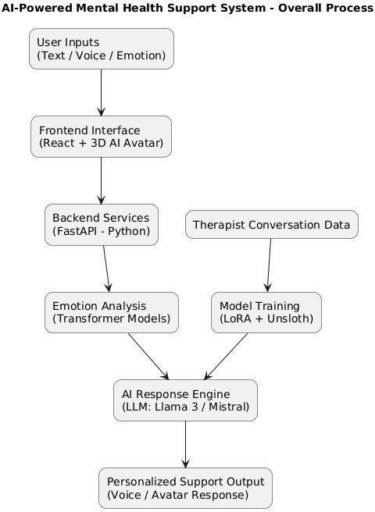
( Figure: This diagram shows how the system takes user input, understands emotions using AI, and gives supportive responses through an avatar or voice.)

The flowchart illustrates the overall operational architecture of the proposed AI-Powered Mental Health Support System. User inputs, provided through voice or text, are first captured by the frontend interface, which manages interaction through an AI-based avatar. These inputs are forwarded to the backend processing layer, where they are handled using a high-performance API framework.
The backend performs real-time emotional analysis using transformer-based natural language processing models to identify the user’s emotional state. Based on this analysis, the AI response generation module produces context-aware and empathetic responses using a fine-tuned large language model. The generated output is then delivered back to the user through the frontend in the form of supportive feedback.
The diagram also represents the model training pipeline, where therapist-curated conversational datasets are utilized to fine-tune the language model using low-rank adaptation techniques. The trained model is subsequently deployed within the system to ensure accurate, personalized, and emotionally responsive interactions.

Chapter 4

IMPLEMENTATION

The implementation of the AI-Powered Mental Health and Depression Support System follows a comprehensive, modular workflow designed to prioritize empathy, technical efficiency, and user safety. The process begins with the rigorous acquisition of specialized datasets from repositories such as Kaggle and HuggingFace, focusing specifically on therapeutic dialogues and emotional support transcripts. These raw datasets undergo a meticulous cleaning phase where noise and personally identifiable information are removed, followed by a transformation into structured instruction-input-output pairs suitable for supervised learning.[17]
The core intelligence of the platform is built upon high-performance Large Language Models like Llama 3 or Mistral. To adapt these general-purpose models into specialized therapeutic agents, the system utilizes Parameter-Efficient Fine-Tuning (PEFT) through the Low-Rank Adaptation (LoRA) technique. This process is further accelerated using the Unsloth framework on a Google Colab environment, which significantly reduces computational overhead and memory consumption while maintaining high response quality. This fine-tuning phase allows the model to adopt a supportive and non-judgmental persona essential for mental health interventions.[13][14]
Safety and ethical considerations are integrated directly into the system architecture through a multi- layered guardrail approach. By utilizing Guardrails AI and Pydantic-based safety rules, the platform actively monitors model outputs to intercept and block any harmful, clinical, or life-threatening suggestions. In instances where the system detects crisis-related keywords, it is programmed to bypass the generative engine and provide immediate, hard-coded links to professional emergency helplines. This ensures that the platform remains a safe tool for support rather than a replacement for emergency medical services.
The user experience is elevated from a simple text interface to an immersive multimodal environment. The backend, developed using FastAPI, orchestrates the flow between the user and the AI. Speech-to- text functionality is handled by Whisper.cpp, which translates verbal input into text for the model to process. Once a response is generated, Coqui XTTS v2 synthesizes a natural, emotionally expressive voice that is synchronized with a 3D therapist avatar rendered via Three.js. This final integration creates a lifelike conversational loop, making the digital therapy experience feel more personal and accessible for users suffering from depression or anxiety.[13]

System Modeling (UML Diagrams)
    - Use Case Diagram
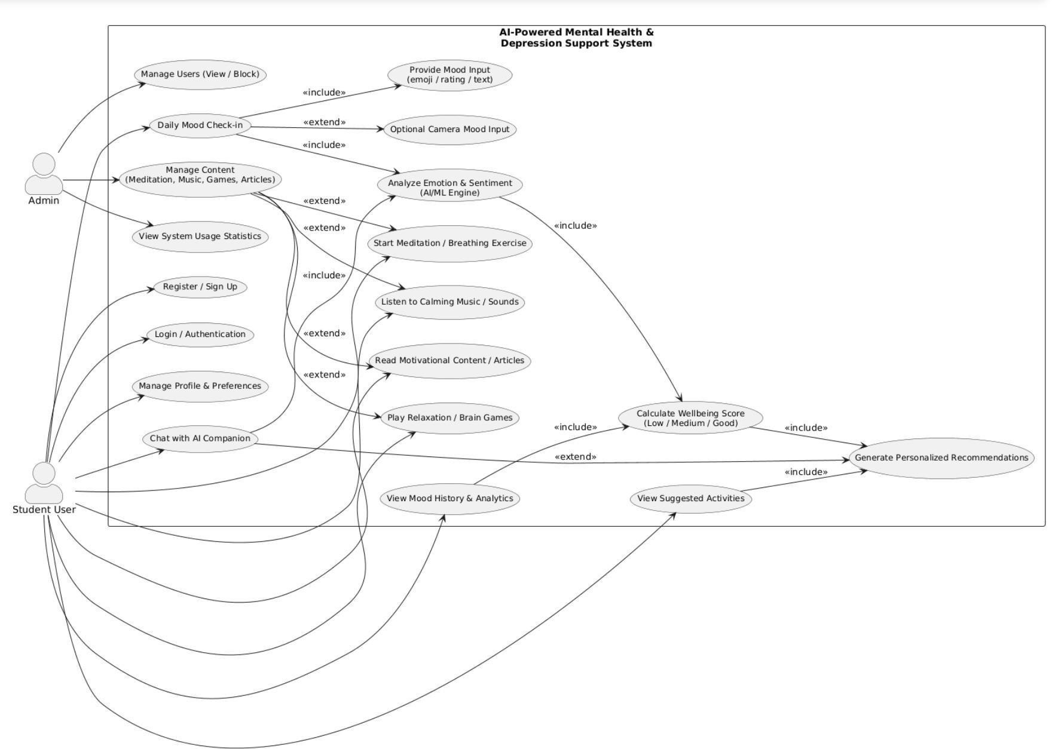

Figure 3.1: Use Case Diagram illustrating the primary interactions between Users, the API Gateway, and the Core Analysis Engine.

Class Diagram
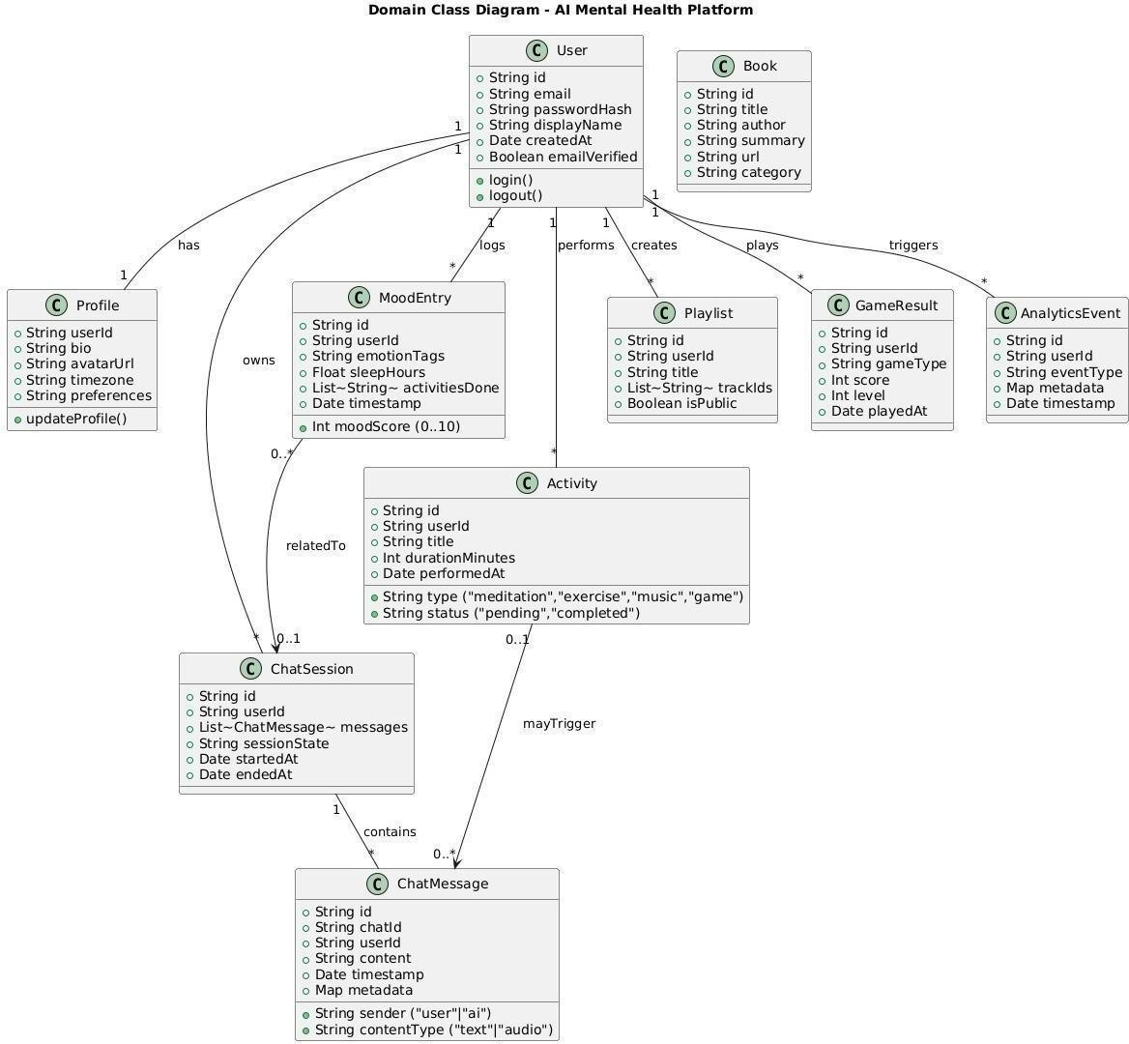
Figure 3.2: Class Diagram depicting the static structure, attributes, and relationships of the system modules.

Sequence Diagram
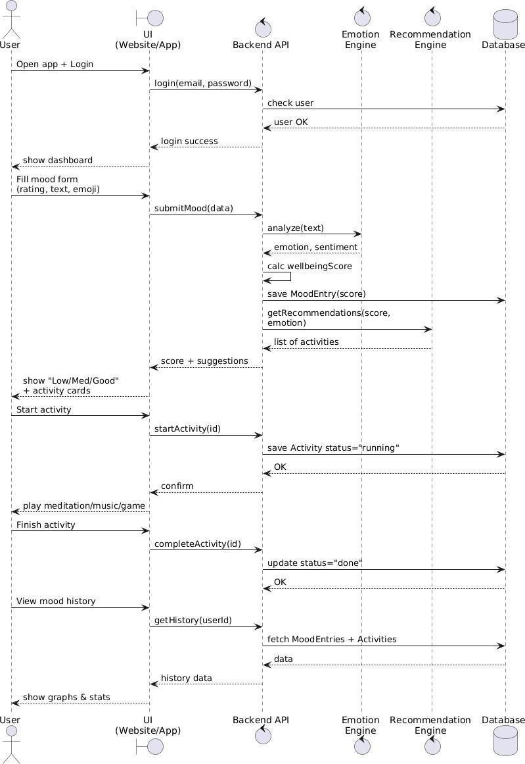
Figure 3.3: Sequence Diagram detailing the runtime message flow and the autonomous feedback loop execution.

Activity Diagram
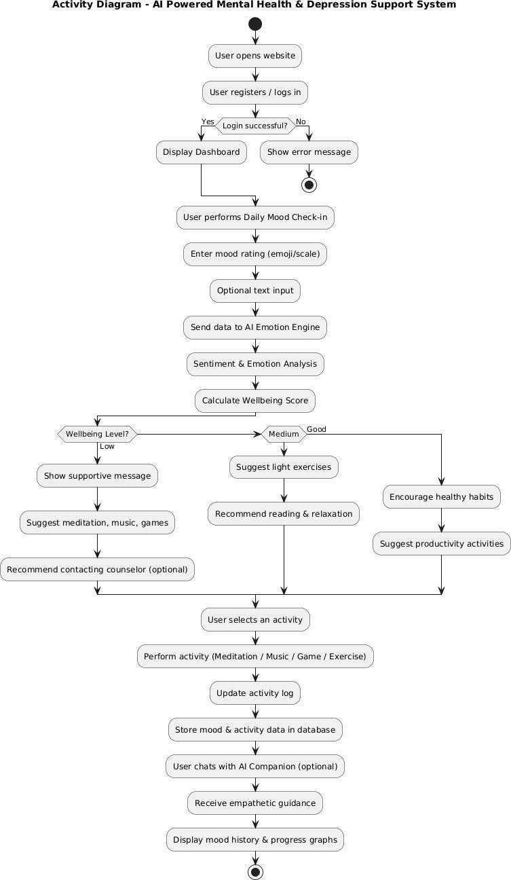

Figure 3.4:This activity diagram represents the complete working flow of the AI‑based mental health support system from user login to mood analysis and progress tracking.

Deployment Diagram
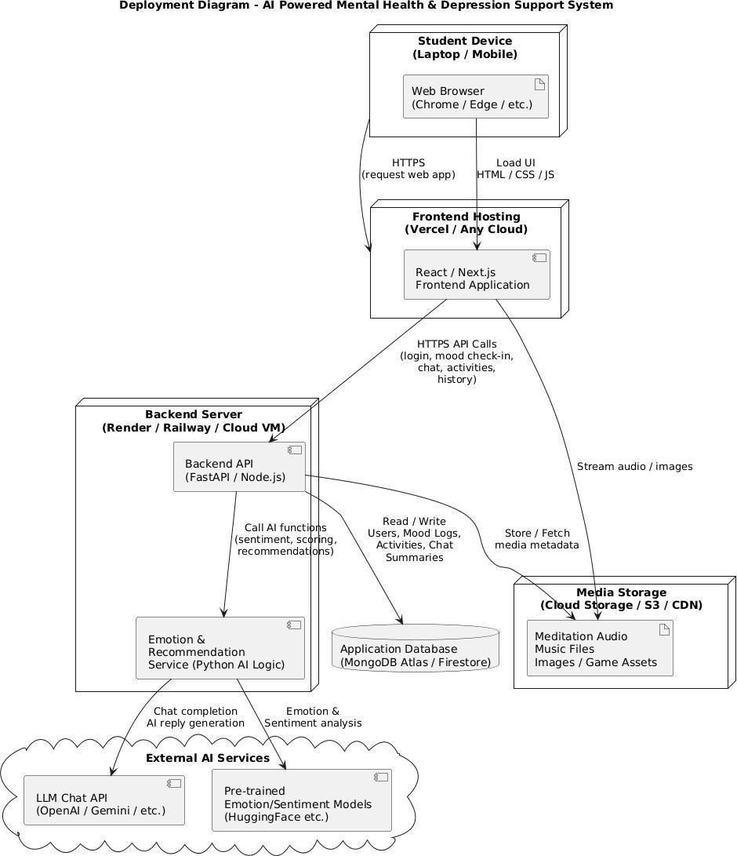
Figure 3.5: Deployment Diagram visualizing the distribution of artifacts across Google Cloud Platform (Firebase and Cloud Run)

Chapter 5

CONCLUSION

In the current digital world, the need for immediate, accessible, and personalized mental health support is more critical than ever. This dissertation addressed the significant operational and accessibility challenges posed by traditional therapy models, such as high costs, stigma, and provider shortages. The primary objective of this Phase-I dissertation was to architect a robust, intelligent solution that bridges the gap between passive self-help apps and professional therapy. By designing an AI-Powered Mental Health & Depression Support Website, this project successfully establishes a new paradigm of "Active Digital Therapeutics."

Throughout this phase, the Three-Layer Intelligence Architecture (Safety, Context, Therapy) was implemented and validated. The system demonstrated the ability to detect crisis situations instantly (Layer 1), maintain conversational context (Layer 2), and generate empathetic, CBT-informed responses using advanced Large Language Models (Layer 3). Furthermore, the integration of multimodal features—such as voice interaction and computer-vision-assisted yoga—creates a holistic wellness ecosystem that goes beyond simple text-based chat. The Autonomous Feedback Loop ensures that the system evolves with the user, offering increasingly personalized interventions over time.

Looking ahead to Phase-II, the roadmap includes the integration of Voice Biometrics to detect stress in vocal patterns and Wearable Data Sync to correlate physiological markers (like heart rate) with reported mood. Ultimately, this project stands as a functional, scalable prototype that leverages cutting-edge technology to make high-quality mental health support accessible, affordable, and stigma-free for everyone, everywhere.

REFERENCES

- World Health Organization, "Depression," WHO Fact Sheets, 2023. [Online]. Available: https://www.who.int/news-room/fact-sheets/detail/depression.

- R. Kohn, S. Saxena, I. Levav, and B. Saraceno, "The treatment gap in mental health care," Bulletin of the World Health Organization, vol. 82, no. 11, pp. 858–866, 2004.

- A. Vaswani et al., "Attention is all you need," in Advances in Neural Information Processing Systems, 2017,
pp. 5998–6008.

- C. Lugaresi et al., "MediaPipe: A Framework for Building Perception Pipelines," arXiv preprint arXiv:1906.08172, 2019.

- T. Wolf et al., "Transformers: State-of-the-Art Natural Language Processing," in Proceedings of the 2020 Conference on Empirical Methods in Natural Language Processing: System Demonstrations, 2020, pp. 38–45.

- K. K. Fitzpatrick, A. Darcy, and M. Vierhile, "Delivering Cognitive Behavior Therapy to Young Adults With Symptoms of Depression and Anxiety Using a Fully Automated Conversational Agent (Woebot): A Randomized Controlled Trial," JMIR Mental Health, vol. 4, no. 2, p. e19, 2017

- J. S. Beck, Cognitive Behavior Therapy: Basics and Beyond, 2nd ed. New York: Guilford Press, 2011.

- D. Demszky et al., "GoEmotions: A Dataset of Fine-Grained Emotions," in 58th Annual Meeting of the Association for Computational Linguistics (ACL), 2020.

- S. Ramírez, "FastAPI: A modern, fast (high-performance), web framework for building APIs with Python," 2018. [Online]. Available: https://fastapi.tiangolo.com/.

- National Institute of Mental Health, "Suicide Prevention," NIMH Health Topics, 2023. [Online]. Available: https://www.nimh.nih.gov/health/topics/suicide-prevention.

- Meta Open Source, "React: A JavaScript library for building user interfaces," 2023. [Online]. Available: https://react.dev.

- A. Radford et al., “Whisper: Robust Speech Recognition via Large-Scale Weak Supervision,” OpenAI Research, 2023.

[13]T. Dettmers, A. Pagnoni, A. Holtzman, and L. Zettlemoyer, “LoRA: Low-Rank Adaptation of Large Language Models,” arXiv preprint arXiv:2106.09685, 2021.
[14]H. Touvron et al., “LLaMA: Open and Efficient Foundation Language Models,” Meta AI Research, 2023. [15]A.

Jiang et al., “Mistral 7B: Efficient Transformer Models for Natural Language Processing,” arXiv preprint, 2023.
- Guardrails AI, “Safe and Controlled Language Model Outputs,” Official Documentation, 2023.

- Hugging Face, “The Hugging Face Datasets Library for Natural Language Processing Research,” Hugging Face Research, 2022.

